12.Create a new NotebookLM project titled: “My Chapter Revision Notes.”

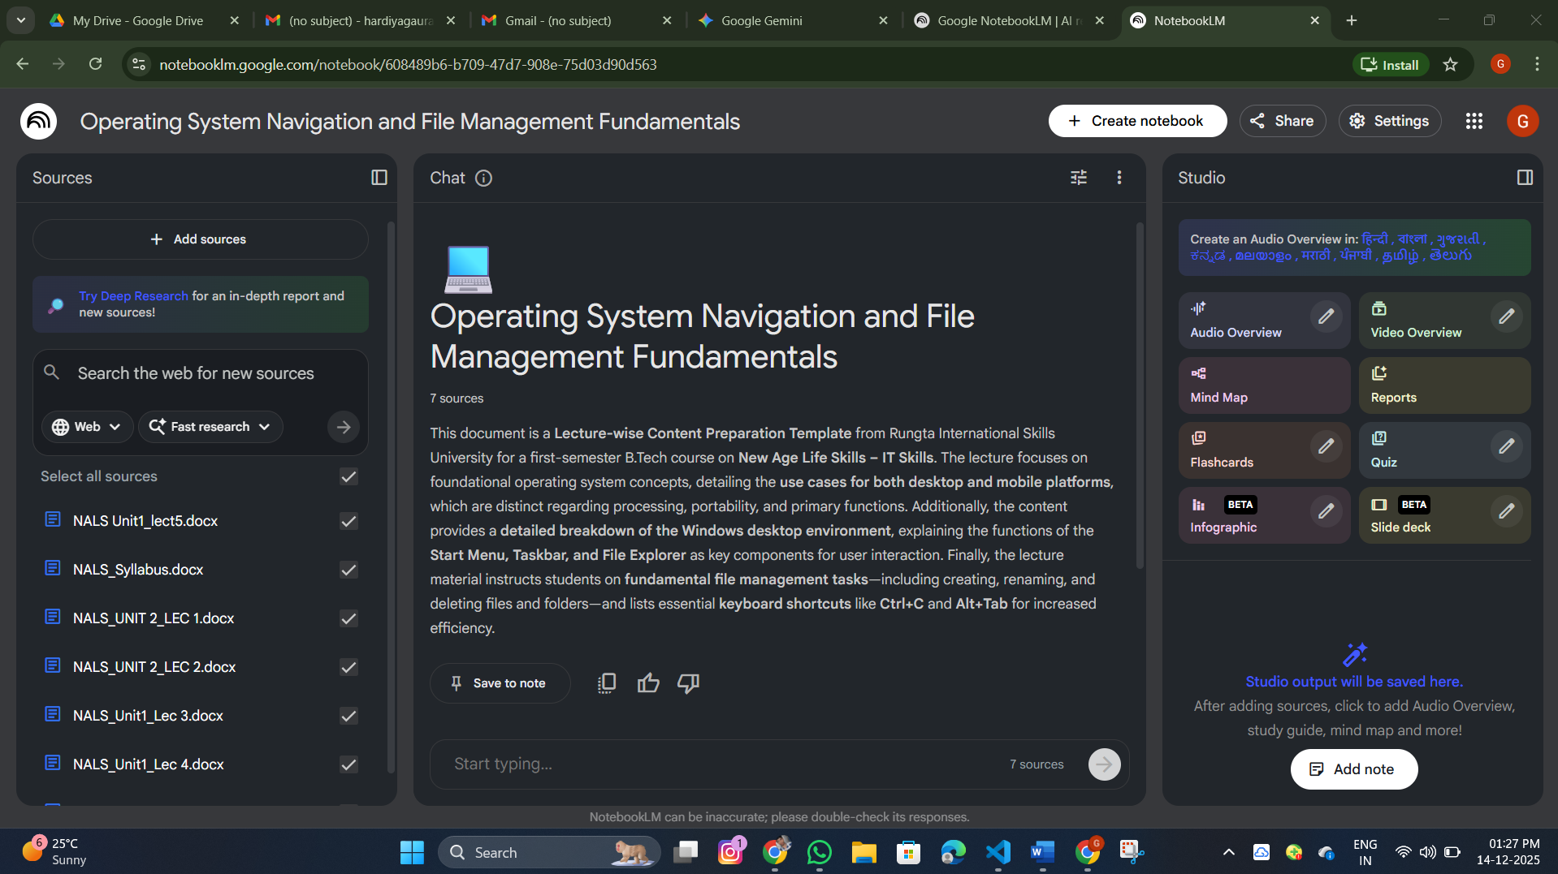

3: AI Generation
With both sources uploaded and active in the project, use the Suggested Actions or the main prompt box within NotebookLM to generate the following three outputs.
Required Output | Action/Prompt to Use
i. Combined Study Guide | Prompt: "Create a comprehensive study guide by combining and synthesizing the key information from all uploaded sources."
ii. Flashcards | Prompt: "Generate 10 flashcards (Question/Answer format) covering the most important definitions and dates from all sources."
iii. Concept Map / Explanation | Prompt: "Explain the main topic of this chapter in simple terms and outline the core concepts in a structured format."

4: Manual Verification
This is the most critical part of the assignment. You must manually read and cross-reference the AI-generated outputs (Study Guide, Flashcards, and Explanation) against your original uploaded sources.
- Check i. Incorrect Facts: Does NotebookLM cite a wrong date, definition, or person? (e.g., Did it mix up information between the two sources?)
- Check ii. Repeated Information: Does the Study Guide have the same fact listed under two different headings?
- Check iii. Missing Important Points: Did NotebookLM omit a crucial, bolded definition or a major step/stage that was present in your original PDF notes?

